Specifications

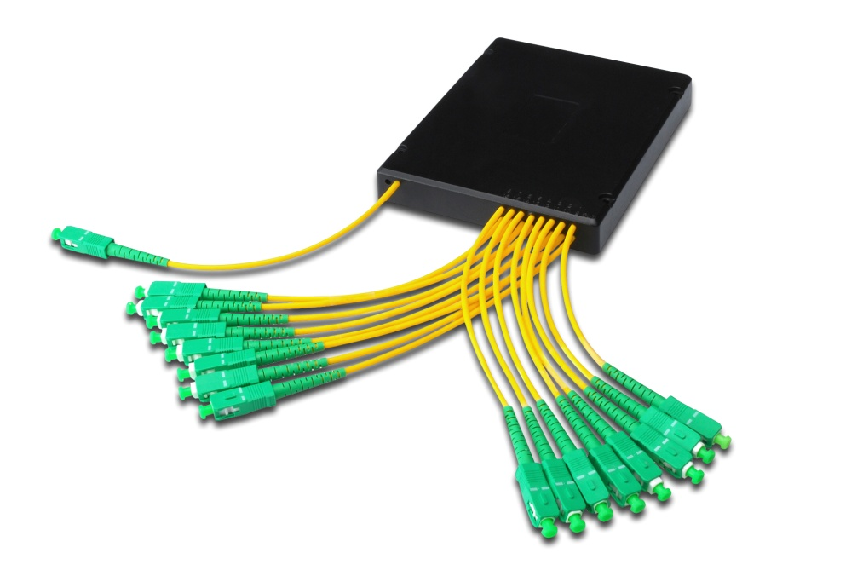
- Low Insertion loss
- Low PDL
- Good channel-to-channel uniformity
- Compact Design
- Wide Operating Wavelength: From 1260nm to 1650nm
- Wide Operating Temperature: From -40°C to 85°C
- High Reliability and Stability
- Applications: FTTX Systems, PON Networks, CATV Links, Optical Signal Distribution
- Compliance: Telcordia GR-1209-CORE, Telcordia GR-1221-CORE, RoHS

Entry
Exit

For example:
 |  | Connector type |  | Entry (Number of fibers) |  | Exit (Number of fibers) |  | Fiber type  (all cables) |  | Cable lenght in meter  (all cables)
ALWL | - | SC | - | 1 | X | 16 | - | 1 | - | 1

Available Connector types:
Connector: | SC | SC |  | FC | FC |  | LC | LC |  | ST | ST |  | E2000 | E2000
Polish: | APC | UPC |  | APC | UPC |  | APC | UPC |  | APC | UPC |  | APC | UPC
Connector type: | SCA | SC |  | FCA | FC |  | LCA | LC |  | STA | ST |  | E20 | E2A

Available Fiber types:
1 | = | OS2 | Singlemode 9/125
2 | = | OM1 | Multimode 62,5/125
3 | = | OM2 | Multimode 50/125
4 | = | OM3 | Multimode 50/125
5 | = | OM4 | Multimode 50/125

